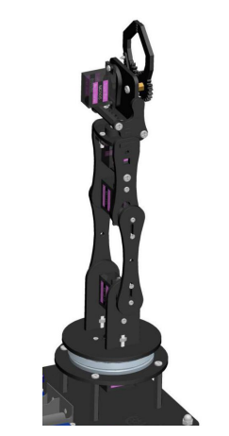**Standardization of Adeept Robot Arm (meech robot)**

(Port D11)(Servo 5) end of arm tooling – jaw 🡪

(D3)(Servo 4) wrist joint 🡪

(Port D5)(Servo 3) middle joint (above hip joint) 🡪

(Port D6)(Servo 2) Joint (above base) 🡪

(Port D9)(Servo 1) rotating BASE 🡪